Rare variant burden complements polygenic risk in breast cancer and is associated with earlier diagnosis
Zimeng Yu¹, Yikai Dong²
¹Program in Computational Biology and Bioinformatics, Yale University, New Haven, CT 06520 USA.
²Emory University, Atlanta, GA, 30322 USA.

Abstract
Breast cancer affects approximately one in eight US women during their lifetime, and about 10% of new cases occur before age 45. Polygenic risk scores (PRS) are associated with breast cancer risk, and previous studies have evaluated PRS alongside pathogenic-variant carrier status. Whether a continuous, gene-effect-weighted rare-variant burden adds information beyond PRS, and whether the two genetic measures relate similarly to diagnosis age, remain unclear. We studied these questions using whole-genome sequencing and electronic health record data from roughly 8,000 breast cancer cases and 134,727 controls of genetically inferred European ancestry in the All of Us Research Program. In joint case-status models, increases in PRS and rare-variant burden (Burden_{rare}) were associated with higher odds of breast cancer (odds ratios, 1.55 and 1.27, respectively). Adding both scores and their interaction to covariates increased the cross-validated area under the receiver operating characteristic curve from 0.745 to 0.782. The PRS odds ratio differed between noncarriers and carriers (1.56 versus 1.25), suggesting that their effects are not simply multiplicative. We then examined whether the same genetic measures were associated with recorded age at diagnosis among cases. In eligible cases, each standard deviation increase in Burden_{rare} was associated with diagnosis 1.82 years earlier, compared with 0.44 years earlier for PRS. The proportion carrying a qualifying rare variant decreased from 26.5% among cases diagnosed before age 35 to 3.2% among those diagnosed at age 70 or older. Higher breast cancer risk can itself produce an earlier mean diagnosis age among cases, so we compared observed age associations with those expected from age-scale risk models under age-constant hazard ratios. Notably, the PRS association was consistent with its risk-based expectation, whereas the Burden_{rare} association was stronger than expected. In this common whole-genome sequencing framework, the weighted rare-variant burden adds information beyond PRS for breast cancer case status and shows a more pronounced association with early diagnosis, guiding future studies of risk and diagnosis timing.

Introduction
Both common and rare germline variation contribute to breast cancer susceptibility. Genome-wide association studies have identified many common risk loci, and a polygenic risk score (PRS) combines their effects. A score developed by the Breast Cancer Association Consortium from 313 variants was associated with breast cancer risk in prospective cohorts^{[1]}. Rare pathogenic variation includes protein-truncating variants (PTVs) and missense variants classified as pathogenic or likely pathogenic in susceptibility genes. Large case-control studies have estimated elevated risks for variants in BRCA1, BRCA2, PALB2, ATM, CHEK2, and other genes, with the strength of association depending on the gene and variant class^{[2,3]}.
Previous studies have estimated PRS associations within BRCA1 and BRCA2 carriers^{[4,5]}, and carriers of other susceptibility-gene variants^{[6]}. Population biobanks^{[7,8]} and larger case-control studies have also examined PRS and pathogenic-variant carrier status across broader samples^{[9,10]}. These analyses generally classify rare variation by carrier status or gene. However, the added value of a continuous burden score that sums qualifying variants across genes beyond PRS for breast cancer case status remains uncertain. Joint modeling also allows us to test whether the PRS association with breast cancer case status differs between carriers and noncarriers.
Among women who develop breast cancer, age at diagnosis varies widely, and the genetic measures associated with case status may relate differently to earlier diagnosis. In US surveillance data, the median diagnosis age is 64 years, but about 10% of breast cancers are diagnosed before age 45^{[11]}. Age-specific breast cancer risks have been estimated for pathogenic-variant carriers and for PRS^{[3,8]}. A lower mean diagnosis age among cases with higher genetic scores does not by itself establish a stronger effect at younger ages, because an age-constant increase in breast cancer risk can produce the same pattern. It remains unclear whether PRS and a gene-weighted rare-variant burden have similar associations with age at diagnosis, or whether either association exceeds what its breast cancer risk association alone would predict under age-constant relative effects.
In this study, we used whole-genome sequencing and electronic health records from participants of genetically inferred European ancestry in the All of Us Research Program^{[12,13]} to evaluate the separate and joint associations of PRS and a continuous rare-variant burden weighted by external gene-specific effects (${Burden}_{rare}$) with breast cancer case status. Among cases, we examined the associations of both scores with recorded age at diagnosis. Both scores were independently associated with case status and improved breast cancer risk prediction; the PRS association was weaker in carriers than in noncarriers. Among cases, Burden_{rare} was more strongly associated with earlier diagnosis than PRS. Age-scale comparisons showed that the PRS age association was compatible with its risk-based expectation, whereas the burden association was stronger than expected. This joint analysis shows that the two sources of inherited risk contribute differently to case status and recorded diagnosis age.

Methods

Study population
We used the All of Us controlled-tier Curated Data Repository (CDR) version C2025Q4R6 and its short-read whole-genome sequencing (WGS) callsets^{[13]}. Eligible participants were those recorded as female sex at birth with WGS data. All of Us applies sex-concordance checks before release, so we did not exclude participants again on inferred genetic sex. We restricted the analysis to genetically inferred European ancestry, using the program’s ancestry predictions and requiring a predicted European label with a maximum posterior probability above 0.75. The same rule was applied to cases and controls. The first ten genetic principal components used for adjustment were taken from the pca_features field of the All of Us ancestry predictions. We removed related individuals by keeping a maximal unrelated set among pairs with KING kinship $>$0.1^{[14]}, and removed samples with genotype missingness above 3%. The flow of participants is shown in Figure 1.

Phenotypes
Cases were participants with at least one EHR condition record mapping to the SNOMED concept “Malignant tumor of breast” (OMOP concept 4112853) or any of its descendants. Controls were eligible participants with no EHR record of a malignant neoplasm (OMOP concept 443392 or its descendants). Recorded age at diagnosis was calculated from the earliest qualifying breast cancer EHR record. Age at last observation was the later of the last EHR record and the date of death. Case-status models required a non-missing age at last observation, excluding 2,051 participants, all controls. The age-at-diagnosis analysis additionally excluded 532 cases whose earliest breast cancer record was also their first EHR record, because the record date could reflect a diagnosis made before EHR follow-up began. In a sensitivity analysis, cases were required to have at least two qualifying records.

Polygenic risk score
We calculated the PRS using PGS000004 from the PGS Catalog, which originally comprised 313 loci^{[1,15]}, harmonised to GRCh38. Variants were matched to the All of Us array-and-common-allele-frequency (ACAF) callset by chromosome, position and alleles. Where strand or allele orientation was ambiguous, candidate records were resolved by comparing the cohort allele frequency with the published effect-allele frequency. In total, 304 of 313 variants were matched: 281 matched directly, 23 were resolved by allele frequency, one remained ambiguous and eight were absent. Missing effect-allele dosages were replaced with the cohort mean dosage at each locus. Based on published evidence, we excluded two matched PRS loci in linkage disequilibrium with CHEK2 c.1100delC^{[16]}. This avoided counting that variant twice, since it also enters the rare-variant burden. Of the 311 loci remaining after this exclusion, 302 were matched and scored in All of Us. Scores were standardized within the full case-status analysis cohort and restandardised within eligible cases for the age-at-diagnosis analysis. In sensitivity analyses we restricted the score to the 281 directly matched variants and repeated the scoring without mean imputation. For participant i, the score was the weighted sum of effect-allele dosages across retained loci:
$${PRS}_{i}=\sum_{j∈J}{w_{j}}d_{ij}$$
Here J is the set of matched loci after removing the two CHEK2-tagging variants, wⱼ is the per-effect-allele log odds ratio for breast cancer estimated in the original PRS development data and supplied with PGS000004^{[1,15]}, rather than re-estimated in All of Us, and dᵢⱼ is the effect-allele dosage (0, 1 or 2), replaced by the cohort mean dosage when missing.

Rare-variant burden
The burden panel comprised 13 breast cancer susceptibility genes for which Rowlands et al. reported combined pathogenic-variant odds ratios: ATM, BARD1, BRCA1, BRCA2, CHEK2, PALB2, RAD51C, RAD51D, TP53, CDH1, NF1, PTEN and STK11^{[17]}. Qualifying PTVs were stop-gained, frameshift, splice-donor and splice-acceptor variants with both the qualifying consequence and high-confidence LOFTEE annotation on the same retained transcript of the same gene^{[18]}; eligibility was not restricted to the canonical transcript. Qualifying missense variants required germline pathogenic/likely pathogenic classification in ClinVar (13 September 2026 release), at least two review stars, and relevant disease and inheritance assertions. Low-penetrance variants, risk alleles, conflicting classifications and opposing benign/likely benign assertions were excluded; unresolved records were held out. Both classes required a known, minor allele frequency below 1% in the All of Us European-ancestry callset. We required variants to pass site- and genotype-level quality filters. Carrier genotypes required genotype quality ≥ 20 and target-alternate allele fraction 0.30–0.80 for heterozygous or ≥ 0.80 for homozygous-alternate calls. Allele fraction was the target-alternate allelic depth divided by total allelic depth after normalized-allele matching. Missing required QC failed inclusion; no blanket read-depth threshold was applied. A carrier had at least one qualifying PTV or missense variant in any panel gene.
${Burden}_{\text{rare}}$ was the sum, over panel genes in which a participant carried a qualifying variant, of the gene’s log odds ratio. Gene weights came from the combined PTV and non-PTV pathogenic-variant estimates in Rowlands et al.^{[17]}. These are approximate external gene-level weights because the source variant definitions differ from ours. Multiple qualifying variants within one gene contributed once; variants in different genes contributed separately. To assess the imprecise STK11 weight (OR 1.60, 95% CI 0.48–5.30), we compared the full panel with a twelve-gene panel excluding STK11, using the same participants, PRS, covariates and cross-validation folds. Explicitly, the participant-level score was:
$${Burden}_{rare,i}=\sum_{g∈G}{\ln\left({OR}_{g}\right)} I_{ig}$$
G is the set of 13 panel genes, ORg is the published combined pathogenic-variant odds ratio for gene g, and Iᵢg is an indicator that equals 1 when participant i carries at least one qualifying PTV or missense variant in that gene and 0 otherwise. Multiple qualifying variants within a gene therefore contributed only once.

Statistical analysis
Breast cancer risk models. We fitted logistic regression models to estimate the association of PRS and standardized ${Burden}_{\text{rare}}$ with breast cancer case status and to assess their interaction. The full model was:
$$logit\left[\operatorname{Pr}\left(Y_{i}=1\right)\right]=β_{0}+β_{P}P_{i}+β_{B}B_{i}+β_{PB}\left(P_{i}×B_{i}\right)+γ^{T}X_{i}$$

Here Yi denotes case status, Pi and Bi are the standardised PRS and Burdenrare, respectively. The interaction coefficient βPB measures departure from multiplicative odds. The covariate vector Xi includes age at last EHR observation, the first ten genetic principal components PCs 1–10, sequencing center and sequencer model. Genetic PCs were included for population structure within the European ancestry sample. “Age at last EHR observation” provided a common age measure for cases and controls for differences in attained age when case status was assessed. Sequencing center and sequencer model identifies adjusted for potential technical differences in genotype measurement.
Five models were compared: covariates only, covariates plus PRS, covariates plus ${Burden}_{\text{rare}}$, an additive model with both scores, and an interaction model with both scores and their product. Each model was fitted separately. Associations are reported as odds ratios per standard deviation, with 95% CIs calculated by heteroskedasticity-robust (HC1) standard errors.
Prediction was evaluated with 5-fold cross-validation repeated 10 times, stratified jointly on case status and carrier status. Within each fold, standardization parameters were estimated from the training data and applied to the validation data. Within each repeat, out-of-fold predictions were pooled across the five validation folds, and paired AUC differences were assessed using DeLong’s Method[citation, Delong, 1998].

BurdenrareβP=βPB=βB=0βB=βPB=0βP=βPB=0βPB=0
Age at diagnosis among cases. We fitted linear models of recorded age at breast cancer diagnosis among eligible cases. The full model was:
$$A_{i}=α_{0}+α_{P}P_{i}+α_{B}B_{i}+α_{PB}\left(P_{i}×B_{i}\right)+ω^{⊤}W_{i}+ε_{i}$$

Here, Ai is the recorded age at breast cancer diagnosis for case $i$, and $P_{i}$ and $B_{i}$ are standardized PRS and Burdenrare, respectively. The covariate Wi contains ten genetic PCs 1-10, sequencing center and sequencer model. ωω contains their coefficients and εi is the residual error. The interaction coefficient $α_{PB}$measures departure from additivity on the diagnosis-age scale.
We compared five models: covariates only; PRS plus covariates; Burden_{rare} plus covariates; an addictive model with both scores, and the full model with their interaction. Each model was fitted separately using ordinary least squares with HC1 standard errors. Each score’s contribution was quantified by the reduction in $R²$.

$$A_{i}=α_{0}+α_{P}P_{i}+α_{B}B_{i}+α_{PB}\left(P_{i}×B_{i}\right)+ω^{⊤}W_{i}+ε_{i}$$

PRS association by rare-variant carrier status. To examine whether PRS association also differed by carrier status in a time-to-event analysis, we additionally fitted Cox models with attained age as the time scale within each carrier and noncarrier groups. We fitted a logistic model with PRS standardized in the full case-control cohort, providing a general scale for both groups:
$$\operatorname{logit}{\operatorname{Pr}\left(Y_{i}=1\right)}=α_{s}+β_{s}P_{i}+γ_{s}^{⊤}X_{i}$$
Here Yi=1 represents breast cancer case status, and $s$ is either carrier $c$ or non-carrier $n$. Each model was fitted separately.βcβnexp(βs
To compare PRS association directly, we calculated the carrier-to-noncarrier ratio of odds ratios:
ORc/n=expβc-βn, SEβc-βn=SEβc2+SEβn2.
The standard error of the log odds ratio difference was calculated by:
SEβc-βn=SEβc2+SEβn2.
Here a ratio below 1 indicates a smaller PRS odds ratio in carriers than in noncarriers.
To examine whether the same pattern was present in a time-to-event analysis, we additionally fitted Cox models with attained time scaled age within each carrier group:
$$h_{i,s}\left(t\right)=h_{0,s}\left(t\right)exp\left(θ_{s}P_{i}+ξ_{s}^{T}W_{i}\right).$$
Here t is attained age, h0,st is the group-specific baseline hazard. expexpθₛ is the hazard ratio per standard deviation of PRS. Follow-up began at age 18 or one year after the first EHR record. Follow-up ended until the first breast cancer record or censoring at the earlier were excluded.
Age-scale models and expected age-at-diagnosis associations. To assess whether the observed diagnosis-age associations exceeded those expected from higher breast cancer risk alone, we constructed a reference model in which genetic hazard ratios remained constant across age. A score associated with higher risk can also be associated with earlier diagnosis among cases without having a larger hazard ratio at younger ages. We therefore fitted an additive Cox model with attained age as the time scale, using the entry and censoring rules described above:
$$h_{i}(t) = h_{0}(t) exp[β_{P}P_{i} + β_{B}B_{i} + γ^{T}W_{i}]$$
Here, Pᵢ and Bᵢ denote PRS and Burdenrare, standardized in the full case-control analysis cohort, and Wᵢ contains PCs 1–10, sequencing center and sequencer model. The coefficients βP and βB are age-constant log hazard ratios per standard deviation, γ contains the adjustment-covariate coefficients, and h₀(t) is the baseline hazard.
To translate this risk model into an expected diagnosis-age association, we calculated hazard-weighted mean predictors among participants still under observation and at risk at each case’s diagnosis age. We used these risk-set means to derive the expected component of the case-only age-regression coefficients and compared it with the observed component. Predictor values were expressed on the scales used for the case-only regression. The risk-set weighting, coefficient decomposition and reference regression specification are detailed in Supplementary Methods.
To examine age variation directly, we next fitted Cox models allowing genetic coefficients to differ across four attained-age bands:
$$h_{i}\left(t\right)=h_{0}\left(t\right)\exp\left[\sum_{a=1}^{4}{ρ_{a}^{⊤}}S_{i}1\left\{t∈A_{a}\right\}+λ^{⊤}W_{i}\right]$$
The bands Aₐ were <45, 45–<55, 55–<65 and ≥65 years. The genetic predictor vector Sᵢ contained standardized PRS together with either an any-carrier indicator or separate indicators for BRCA1/BRCA2 carriers and other panel-gene carriers. Exponentiating each coefficient in ρₐ gives the corresponding band-specific hazard ratio. Wᵢ contains the adjustment covariates defined above, and their coefficients λ were held constant across age bands.
Finally, to explore whether declining population-level hazard ratios could arise from earlier events among higher-risk women even when individual-level effects remained constant, we introduced a multiplicative gamma frailty:
$$u_{i}∼\operatorname{Gamma}\left(1/θ,1/θ\right), E\left(u_{i}\right)=1, \operatorname{Var}\left(u_{i}\right)=θ.$$
The gamma distribution was parameterized by shape and rate, with mean 1 and variance θ. We used the age pattern of PRS among noncarriers to constrain the range of θ, then compared the frailty-adjusted expected diagnosis-age coefficients with the observed coefficients. This analysis explored the contribution of unobserved risk heterogeneity and depletion of higher-risk women from later-age risk sets. Parameter constraints and calculations are described in Supplementary Methods.
Sensitivity analyses. We repeated the case-status and age-at-diagnosis analyses with 12-gene panels that excluded STK11 or CDH1, separately. We also restricted qualifying variants to PTVs, tightened the upper allele-fraction threshold for heterozygous TP53 and NF1 calls to 0.70, and lowered the ClinVar review threshold to at least one star. We compared these specifications with the historical nine-gene PTV score and staged updates to its weights, genotype quality control and eligible missense variants; the historical scores retained their original definitions. For case-status prediction, we recalculated out-of-fold ROC curves and AUCs using the repeated cross-validation procedure described above (Supplementary Figures). We also repeated the comparison of earlier and later diagnosis among cases using <40 versus ≥40 years as the threshold.
Disclosure control. In line with the All of Us Data and Statistics Dissemination Policy, no count between 1 and 20 participants (or between 1 and 39 alleles) is reported, either directly or in a form from which it could be derived. Affected cells are shown as $≤20$ and, where needed, a second cell is suppressed so that the first cannot be recovered by subtraction. Test statistics whose inputs include such a cell are not reported.
Software. Analyses used Python with pandas, statsmodels and scikit-learn; Hail 0.2.137; PLINK 2^{[20]}; and bcftools. Analysis code is available at https://github.com/martina-yu/AoU_Comr.

Results

Study cohort
Among 295,706 women with WGS, 150,900 had genetically inferred European ancestry. Relatedness and sample QC left 143,255 participants: 8,528 cases and 134,727 controls (Figure 1). Mean recorded age at diagnosis among cases was 59.9 years (SD 11.8). Cases were older at enrolment than controls (64.0 versus 51.2 years; Table 1). Of 141,204 participants in the case-status model, 3,209 (2.3%) carried a qualifying PTV or missense variant in a panel gene (Figure 2).

Breast cancer case status
In the joint logistic model, the odds ratio for breast cancer case status per standard deviation was 1.55 (95% CI 1.52–1.59) for PRS and 1.27 (1.25–1.29) for Burden_{rare}, each evaluated at the other score’s mean. Their interaction was negative on the multiplicative odds scale (OR 0.972, 95% CI 0.958–0.985; P=6.0×10⁻⁵; Table 2).
The covariate-only model had a mean out-of-fold AUC of 0.745, driven largely by age at last EHR observation. Adding PRS increased AUC by 0.023, and adding Burden_{rare} increased it by 0.014 (Figure 3). The model with both scores and their interaction reached 0.782, an increase of 0.036 over covariates alone and 0.01328 over covariates plus PRS. In the first cross-validation repeat, the latter increase was 0.01328 (95% CI 0.01133–0.01523; paired DeLong P=1.7×10⁻⁴⁰); AUCs varied by less than 0.0003 across ten repeats. Because age at last observation reflects both attained age and the length of EHR follow-up, we interpret the change in AUC rather than the absolute value as the contribution of the genetic scores.

Recorded age at diagnosis among cases
Figure 4 shows the distribution of recorded diagnosis age across PRS groups and carrier status among 7,996 cases. PRS quartiles, defined in the full case-control cohort, were represented across all age bands (Figure 4a). The carrier proportion fell from 26.5% (95% CI 20.1–33.9%) among cases diagnosed before age 35 to 3.2% (2.5–4.2%) among those diagnosed at age 70 or older (Figure 4b). In both the median-split and extreme-PRS comparisons, carriers tended to have younger recorded diagnosis ages than noncarriers (Figure 4c).
In the additive case-only model, each standard deviation increase in Burden_{rare} was associated with diagnosis 1.82 years earlier (95% CI 2.10–1.53 years earlier; P=2.36×10⁻³⁵), compared with 0.44 years earlier for PRS (0.70–0.19 years earlier; P=0.000548; Table 3). Together, the scores explained 2.73% of variation in recorded diagnosis age; removing Burden_{rare} reduced R² by 2.36 percentage points. Figure 5 compares the case-status and diagnosis-age estimates across rare-variant definitions.
Case-status odds ratios and case-only age coefficients changed little across the panel, variant-filter and score-definition analyses (Figure 5a,b). Excluding STK11 changed the joint-model AUC from 0.78151 to 0.78149, the Burden_{rare} odds ratio from 1.269 to 1.268, and its age coefficient from −1.820 to −1.819 years per standard deviation. Across the alternative burden specifications, PRS odds ratios remained near 1.55, Burden_{rare} odds ratios ranged from 1.25 to 1.27, and age coefficients ranged from −0.44 to −0.43 years for PRS and from −1.82 to −1.75 years for Burden_{rare}. The historical nine-gene PTV score is shown separately in Figure 5 because its weights and eligibility rules differed. Supplementary Tables S3 and S5 report the AUC estimates and paired increments.
We then assessed PRS associations within carrier strata. In separate logistic models, the PRS odds ratio was 1.56 (95% CI 1.52–1.60) in noncarriers and 1.25 (1.14–1.37) in carriers (Figure 6a). The corresponding age-scale Cox hazard ratios were 1.51 (1.48–1.55) and 1.19 (1.09–1.30); an exact-date EHR follow-up analysis gave similar estimates. The carrier-to-noncarrier ratio of logistic PRS odds ratios was 0.80 (0.73–0.88), with the same direction across model, panel and case-definition checks (Figure 6b). The exploratory PRS-by-carrier association with recorded diagnosis age was imprecise (interaction +0.98 years per PRS SD, 95% CI −0.08 to 2.04). In case-status models, PRS interactions differed across seven gene categories (heterogeneity P=0.0126); the BRCA1 interaction was the most negative (OR 0.652, 95% CI 0.514–0.828; q=0.0030), while the BRCA2 estimate was 0.786 (0.640–0.965; q=0.0758; Supplementary Table S7 and Figure S1).

Age-scale expectations and age-specific hazard ratios
We next compared the observed case-only age coefficients with those expected if the genetic hazard ratios remained constant across age (Figure 7a). For PRS, the expected association was 0.23–0.30 years earlier per standard deviation, compatible with the observed 0.44 years earlier (P=0.29). For Burden_{rare}, the expected association was 0.72–0.80 years earlier, substantially smaller than the observed 1.82 years earlier (P=3×10⁻¹⁴). In age-band Cox models, the PRS hazard ratio changed little with attained age (ratio per decade, 1.00), whereas the BRCA1/BRCA2 carrier hazard ratio declined from 8.4 before age 45 to 2.7 at age 65 or older (Figure 7b). Gamma-frailty simulations suggested that depletion of higher-risk women from later risk sets could account for much of the carrier hazard-ratio decline, but the observed Burden_{rare} age coefficient remained beyond the frailty-adjusted expectation (Figure 7a,b).

Discussion
In this All of Us cohort, PRS and Burden_{rare} each contributed to breast cancer risk prediction. Their joint association was sub-multiplicative on the odds-ratio scale. Among cases, greater Burden_{rare} was associated with younger recorded diagnosis age; the PRS association was smaller. Together, the scores explained only 2.73% of age-at-diagnosis variation.
The PRS odds ratio per standard deviation (1.55) was close to the 1.61 reported for the 313-variant score in prospective cohorts^{[1]}, despite our use of EHR-defined case status. A weaker relative PRS association in BRCA1/BRCA2 carriers than in noncarriers was also reported in a carrier-stratified study^{[6]}. In our exploratory gene-specific analysis, BRCA1 had the clearest negative interaction. Breast cancer subtype composition or the relevance of an overall PRS to different carrier groups could contribute to this difference^{[5]}; subtype data were not analysed here. An interaction on the logistic scale does not establish biological antagonism or an interaction on the additive-risk scale.
The Burden_{rare} association with younger recorded diagnosis age is consistent with the earlier breast cancer onset reported for PALB2 and CHEK2 frameshift carriers in FinnGen^{[8]}. The PRS association with age was consistent with the range expected from its breast cancer risk association alone.
The analysis was limited to genetically inferred European ancestry. Requiring a European posterior probability above 0.75 excluded some admixed participants, particularly near the European–Middle Eastern ancestry boundary; the results may not generalise to other ancestries. EHR-based phenotypes introduce uncertainty in diagnosis dates, leave some prevalent cases in the age analysis and may classify unrecorded cases as controls. Differences in EHR follow-up inflated the covariate-only AUC, so we interpret changes in AUC rather than its absolute value. The exploratory gene-specific interaction analyses were limited by sparse carrier counts, which required pooling several genes in the gene–PRS model. The external ${Burden}_{\text{rare}}$ weights only approximate our qualifying variant definitions, the STK11 weight is imprecise, and final manual adjudication of variants remains pending. Allele-fraction filtering cannot fully exclude clonal hematopoiesis. The original analysis plan was fixed after an earlier analysis in a related cohort; the full gene panel and gene–PRS diagnostics were developed later. Age-at-diagnosis findings are restricted to cases and may be affected by selection on case status^{[21]}.
Common and rare germline variation both contributed to breast cancer risk prediction in this EHR-linked cohort. ${Burden}_{\text{rare}}$ had a larger association with recorded diagnosis age among cases than PRS; neither score explained much of the variation in that age.

Data availability. Individual-level data are available to registered researchers through the All of Us Researcher Workbench (controlled tier, CDR C2025Q4R6). Aggregate results that meet the dissemination policy and the analysis code are available at https://github.com/martina-yu/AoU_Comr.

Ethics approval and consent to participate. The All of Us Research Program protocol and informed consent materials were approved by the All of Us Institutional Review Board, and participants provided informed consent for research use of their data. This study was a secondary analysis of data accessed through the controlled-tier Researcher Workbench. We did not contact participants or access directly identifiable information. Under the program’s data passport model, project-specific review by the All of Us Institutional Review Board was not required.

Funding. No specific funding was received for this work.

Competing interests. The authors declare no competing interests.

Acknowledgments. We gratefully acknowledge All of Us participants for their contributions, without whom this research would not have been possible. We thank the National Institutes of Health’s All of Us Research Program for making the participant data examined in this study available.

References
1. Mavaddat N, Michailidou K, Dennis J, et al. Polygenic risk scores for prediction of breast cancer and breast cancer subtypes. Am J Hum Genet. 2019;104(1):21–34.
2. Breast Cancer Association Consortium; Dorling L, Carvalho S, Allen J, et al. Breast cancer risk genes—association analysis in more than 113,000 women. N Engl J Med. 2021;384(5):428–439.
3. Hu C, Hart SN, Gnanaolivu R, et al. A population-based study of genes previously implicated in breast cancer. N Engl J Med. 2021;384(5):440–451.
4. Kuchenbaecker KB, McGuffog L, Barrowdale D, et al. Evaluation of polygenic risk scores for breast and ovarian cancer risk prediction in BRCA1 and BRCA2 mutation carriers. J Natl Cancer Inst. 2017;109(7):djw302.
5. Barnes DR, Rookus MA, McGuffog L, et al. Polygenic risk scores and breast and epithelial ovarian cancer risks for carriers of BRCA1 and BRCA2 pathogenic variants. Genet Med. 2020;22(10):1653–1666.
6. Gallagher S, Hughes E, Wagner S, et al. Association of a polygenic risk score with breast cancer among women carriers of high- and moderate-risk breast cancer genes. JAMA Netw Open. 2020;3(7):e208501.
7. Fahed AC, Wang M, Homburger JR, et al. Polygenic background modifies penetrance of monogenic variants for tier 1 genomic conditions. Nat Commun. 2020;11(1):3635.
8. Mars N, Widén E, Kerminen S, et al. The role of polygenic risk and susceptibility genes in breast cancer over the course of life. Nat Commun. 2020;11(1):6383.
9. Gao C, Polley EC, Hart SN, et al. Risk of breast cancer among carriers of pathogenic variants in breast cancer predisposition genes varies by polygenic risk score. J Clin Oncol. 2021;39(23):2564–2573. doi:10.1200/JCO.20.01992.
10. Kalia SS, Boddicker NJ, Yadav S, et al. Development of a breast cancer risk prediction model integrating monogenic, polygenic, and epidemiologic risk. Cancer Epidemiol Biomarkers Prev. 2024;33(11):1490–1499. doi:10.1158/1055-9965.EPI-24-0594.
11. National Cancer Institute. Female Breast Cancer—Cancer Stat Facts. Surveillance, Epidemiology, and End Results Program. https://seer.cancer.gov/statfacts/html/breast.html. Accessed October 17, 2026.
12. The All of Us Research Program Investigators. The “All of Us” Research Program. N Engl J Med. 2019;381(7):668–676.
13. The All of Us Research Program Genomics Investigators. Genomic data in the All of Us Research Program. Nature. 2024;627(8003):340–346.
14. Manichaikul A, Mychaleckyj JC, Rich SS, Daly K, Sale M, Chen WM. Robust relationship inference in genome-wide association studies. Bioinformatics. 2010;26(22):2867–2873.
15. Lambert SA, Gil L, Jupp S, et al. The Polygenic Score Catalog as an open database for reproducibility and systematic evaluation. Nat Genet. 2021;53(4):420–425.
16. Mavaddat N, Ficorella L, Carver T, et al. Incorporating alternative polygenic risk scores into the BOADICEA breast cancer risk prediction model. Cancer Epidemiol Biomarkers Prev. 2023;32(3):422–427. doi:10.1158/1055-9965.EPI-22-0756.
17. Rowlands CF, Allen S, Balmaña J, et al. Population-based germline breast cancer gene association studies and meta-analysis to inform wider mainstream testing. Ann Oncol. 2024;35(10):892–901. doi:10.1016/j.annonc.2024.07.244.
18. Karczewski KJ, Francioli LC, Tiao G, et al. The mutational constraint spectrum quantified from variation in 141,456 humans. Nature. 2020;581(7809):434–443.
19. DeLong ER, DeLong DM, Clarke-Pearson DL. Comparing the areas under two or more correlated receiver operating characteristic curves: a nonparametric approach. Biometrics. 1988;44(3):837–845.
20. Chang CC, Chow CC, Tellier LC, Vattikuti S, Purcell SM, Lee JJ. Second-generation PLINK: rising to the challenge of larger and richer datasets. GigaScience. 2015;4:7.
21. Mitchell RE, Hartley AE, Walker VM, et al. Strategies to investigate and mitigate collider bias in genetic and Mendelian randomisation studies of disease progression. PLoS Genet. 2023;19(2):e1010596. doi:10.1371/journal.pgen.1010596.

Tables
Table 1. Characteristics of the study cohort.
 | Case-status cases | Case-status controls | Age-analysis cases
N | 8,528 | 134,727 | 7,996
Age at diagnosis, years, mean (SD) | 59.9 (11.8) |  | 60.2 (11.8)
Age at diagnosis, years, median [IQR] | 60.7 [51.5-68.4] |  | 61.1 [51.9-68.7]
Age at enrollment, years, mean (SD) | 64.0 (11.6) | 51.2 (16.8) | 64.1 (11.6)
Age at last EHR observation, years, mean (SD) | 68.1 (11.7) | 53.9 (17.0) | 68.2 (11.7)
BMI, kg/m$​^{2}$, mean (SD) | 28.5 (6.7) | 29.4 (7.9) | 28.5 (6.8)
PRS (raw score), mean (SD) | 0.4 (0.6) | 0.1 (0.6) | 0.4 (0.6)
BMI missing, n (%) | 92 (1.1) | 5,107 (3.8) | suppressed (secondary)
Age at last EHR observation missing, n (%) | 0 (0.0) | 2,051 (1.5) | 0 (0.0)
Menopausal status, n (%)
Premenopausal | 620 (7.3) | 49,735 (36.9) | 592 (7.4)
Postmenopausal | 7,610 (89.2) | 75,983 (56.4) | 7,133 (89.2)
Uncertain or unknown | 149 (1.7) | 4,801 (3.6) | suppressed (secondary)
Missing | 149 (1.7) | 4,208 (3.1) | suppressed (secondary)
Smoking status, n (%)
Never | 4,932 (57.8) | 80,136 (59.5) | 4,612 (57.7)
Former or unknown currency | 2,974 (34.9) | 35,699 (26.5) | 2,796 (35.0)
Current | 442 (5.2) | 13,614 (10.1) | suppressed (secondary)
Missing | 180 (2.1) | 5,278 (3.9) | suppressed (secondary)
Self-reported race, n (%)
White | 8,117 (95.2) | 126,790 (94.1) | 7,611 (95.2)
Other, multiple, or not reported | 411 (4.8) | 7,937 (5.9) | 385 (4.8)
Sequencing center, n (%)
Broad Institute | 4,963 (58.2) | 79,319 (58.9) | 4,639 (58.0)
University of Washington | 997 (11.7) | 16,069 (11.9) | 936 (11.7)
Baylor College of Medicine | 2,568 (30.1) | 39,339 (29.2) | 2,421 (30.3)
Sequencer, n (%)
NovaSeq6000 S4 | 8,293 (97.2) | 127,580 (94.7) | suppressed (secondary)
NovaSeq X 25B | 235 (2.8) | 7,147 (5.3) | suppressed (secondary)
Counts between 1 and 20, and cells from which such a count could be derived, are suppressed.

Table 2. Joint logistic model of case status and cross-validated breast cancer risk prediction. Models adjust for age at last EHR observation, PC1–10, sequencing center and sequencer. AUC and ΔAUC are means over ten repeats; 95% CIs and paired DeLong P values are from the first repeat and are not confidence intervals for the repeated-CV means. n=141,204 (8,528 cases).
 | Estimate (95% CI) | $P$​
A. Joint model, full cohort (OR per SD)
PRS | 1.55 (1.52–1.59) | ​< 10⁻³⁰⁰
$${Burden}_{\text{rare}}$$ | 1.27 (1.25–1.29) | 6.9×10⁻²³³
PRS $×$ ${Burden}_{\text{rare}}$ | 0.972 (0.958–0.985) | 6.0×10⁻⁵
B. Out-of-fold AUC, 10 $×$ 5-fold CV (mean; 95% CI from repeat 1)
Covariates-only | 0.7452 (0.7406–0.7498) | –
PRS-only | 0.7682 (0.7637–0.7728) | –
${Burden}_{\text{rare}}$-only | 0.7588 (0.7543–0.7633) | –
PRS+${Burden}_{\text{rare}}$ (no interaction) | 0.7813 (0.7770–0.7858) | –
PRS+${Burden}_{\text{rare}}$ + Interaction (Joint) | 0.7815 (0.7771–0.7859) | –
C. ΔAUC (mean over repeats; repeat-1 DeLong 95% CI and P)
Interaction $-$ Additive | 0.000181 (0.000023–0.000314) | 2.303 × 10⁻²
Additive $-$ Cov | 0.036150 (0.033258–0.039109) | 8.28 × 10⁻¹³⁰
Additive $-$ PRS | 0.013098 (0.011202–0.015021) | 2.81 × 10⁻⁴¹
Additive $-$ Burden | 0.022523 (0.020250–0.024841) | 1.40 × 10⁻⁸²
Interaction $-$ Cov | 0.036331 (0.033380–0.039323) | 4.75 × 10⁻¹²⁷
Interaction $-$ PRS | 0.013279 (0.011326–0.015233) | 1.68 × 10⁻⁴⁰
Interaction $-$ Burden | 0.022704 (0.020388–0.025039) | 1.13 × 10⁻⁸¹
PRS $-$ Cov | 0.023052 (0.020712–0.025432) | 7.58 × 10⁻⁸²
Burden $-$Cov | 0.013627 (0.011661–0.015615) | 1.18 × 10⁻⁴¹
Cov: covariates only; PRS: covariates + PRS; Burden: covariates + Burden; Additive: covariates + Burden + PRS; Interaction: Additive + Burden $×$ PRS
Table 3. Associations of ${Burden}_{\text{rare}}$ and PRS with recorded age at breast cancer diagnosis among cases (n = 7,996).
A. Joint OLS model
Genetic measure | Estimate, years per SD (95% CI) | P value
$${Burden}_{\text{rare}}$$ | −1.82 (−2.10 to −1.53) | 2.36 × 10⁻³⁵
PRS | −0.44 (−0.70 to −0.19) | 0.000548
PRS $×$ ${Burden}_{\text{rare}}$ | 0.12 (−0.16 to 0.41) | 0.400
B. Explained variance
Model | R² | –
Covariates only | 0.30% | –
PRS + Covariates | 0.38% | –
${Burden}_{\text{rare}}$ + Covariates | 2.59% | –
Joint: PRS + ${Burden}_{\text{rare}}$ + Covariates | 2.73% | –
C. Incremental explained variance
Score added | Reduced model | ΔR², percentage points
$${Burden}_{\text{rare}}$$ | PRS + Covariates | 2.36
PRS | ${Burden}_{\text{rare}}$ + Covariates | 0.14
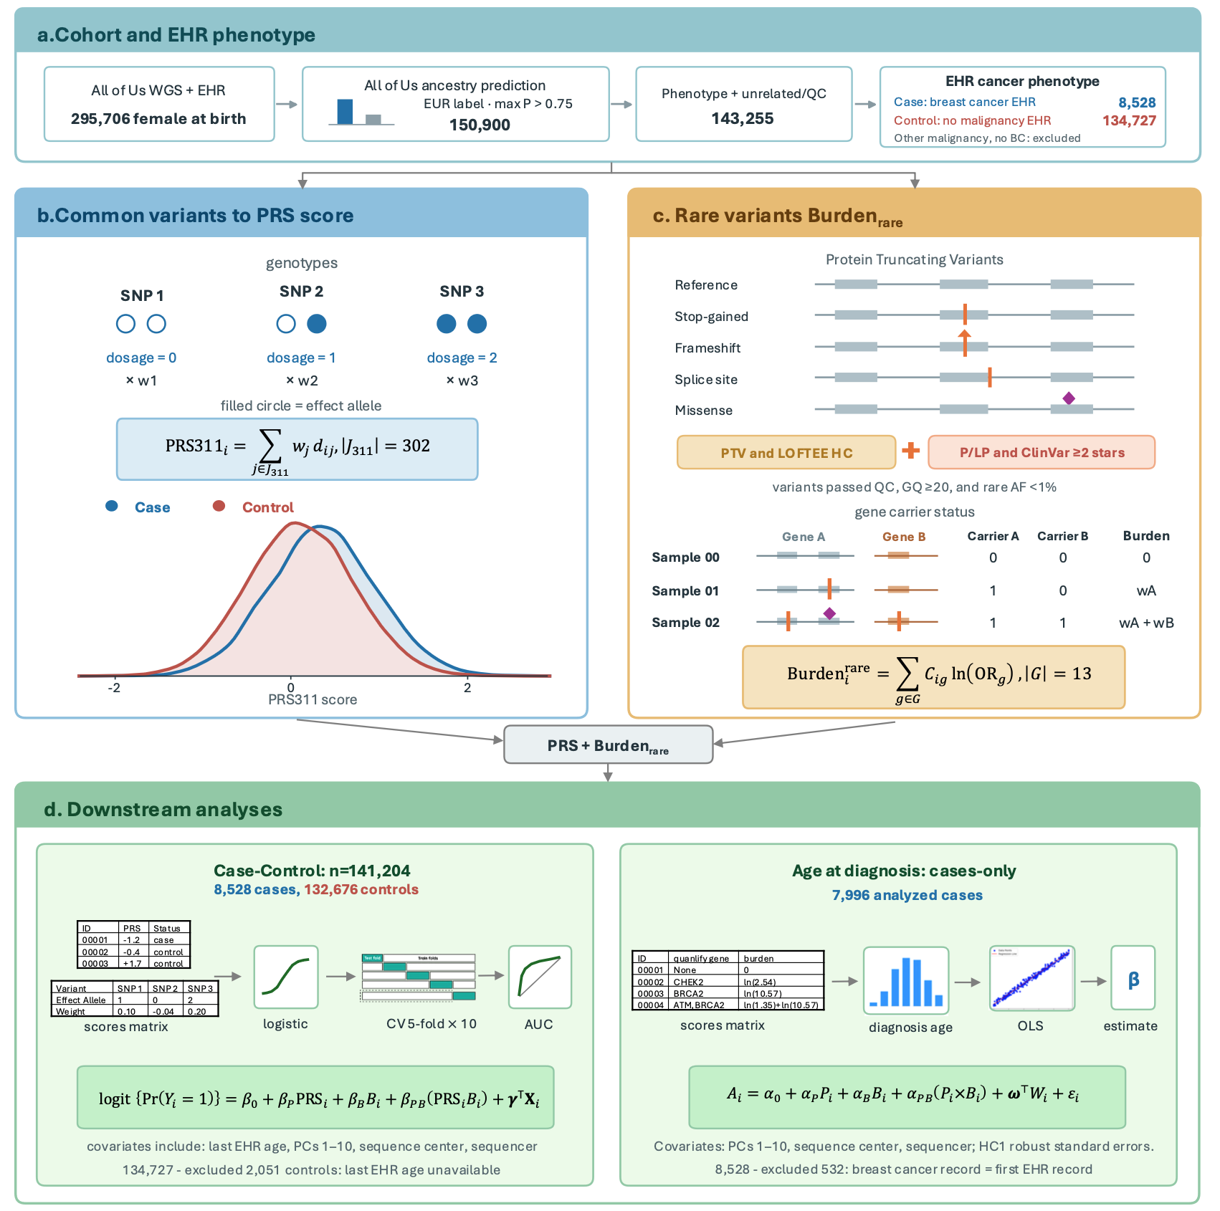
Figure 1. Cohort and genetic analysis workflow. (a) All of Us participants recorded female at birth with whole-genome sequencing and electronic health records underwent ancestry, relatedness, and quality control filtering, yielding 8,528 breast cancer cases and 134,727 controls. (b) PRS combines effect-allele dosages at 302 scored loci; curves show case and control distributions. (c) Schematic protein-truncating and pathogenic/likely pathogenic missense variants illustrate gene-level carrier indicators and the ${Burden}_{\text{rare}}$. (d) Logistic regression assesses case status in 141,204 participants with repeated five-fold cross-validation; cases-only linear regression assesses age at diagnosis in 7,996 cases.
(a)
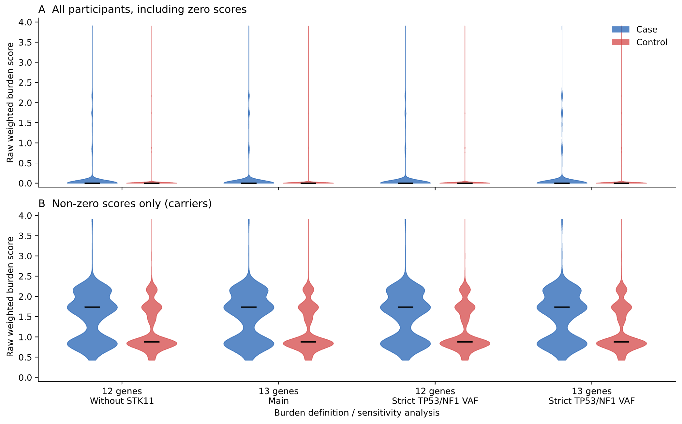
(b)
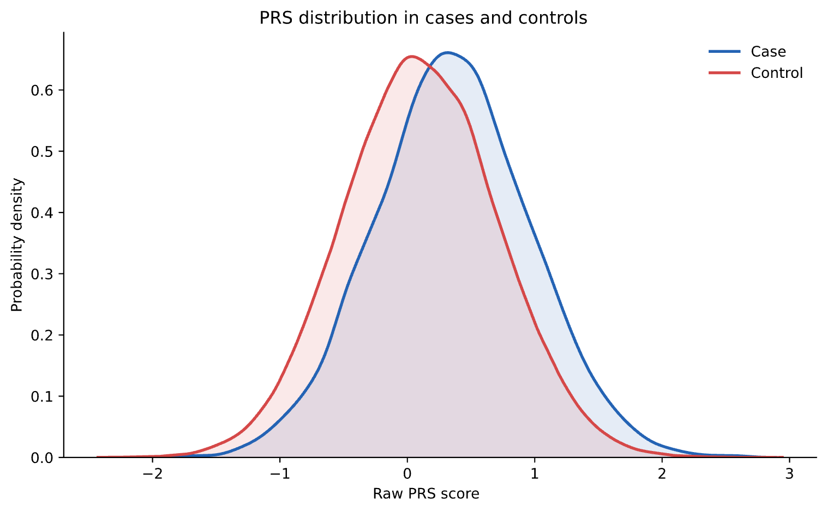
(c)
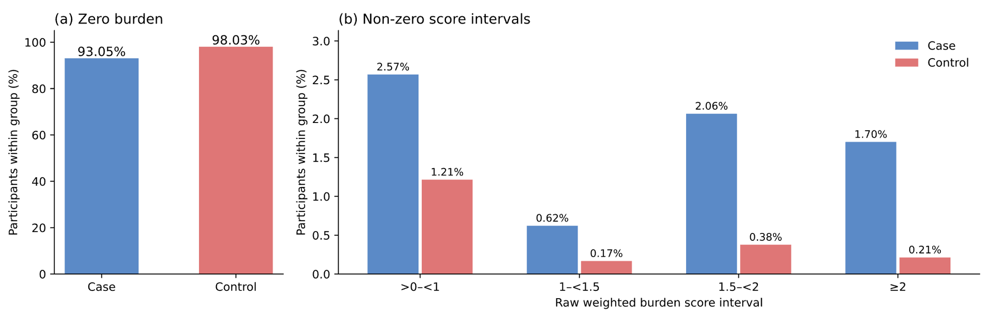
(d)
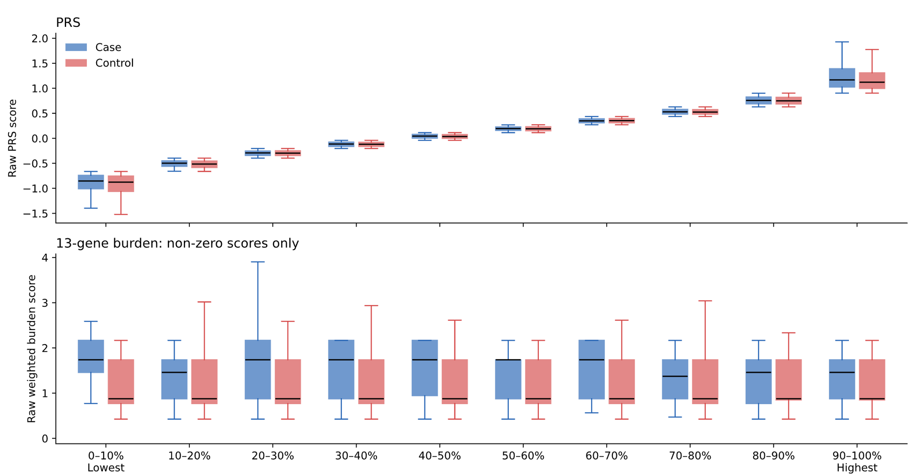
Figure 2. Genetic score distributions in the case-control cohort (n=141,204). (a) ${Burden}_{\text{rare}}$ distributions under the definitions shown, for all participants (top) and carriers (bottom); black bars mark medians. (b) Raw PRS density by case status. (c) Percentages with zero and positive ${Burden}_{\text{rare}}$ within cases and controls. (d) Raw PRS and nonzero ${Burden}_{\text{rare}}$ across full-cohort PRS deciles. Cases are blue and controls red.
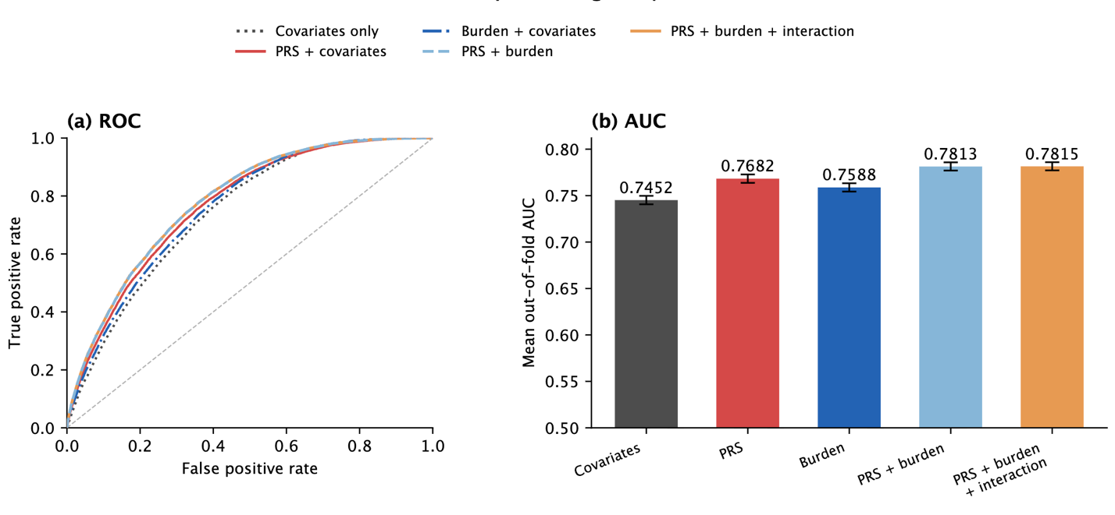
Figure 3. Breast cancer risk model performance using PRS and ${Burden}_{\text{rare}}$. (a) ROC curves from out-of-fold predictions in the first five-fold cross-validation repeat for covariates alone, covariates plus PRS, covariates plus ${Burden}_{\text{rare}}$, covariates plus both scores, and covariates plus both scores and their interaction. (b) Mean out-of-fold AUC across ten repeats of five-fold cross-validation; error bars show DeLong 95% confidence intervals from the first repeat.
(a)
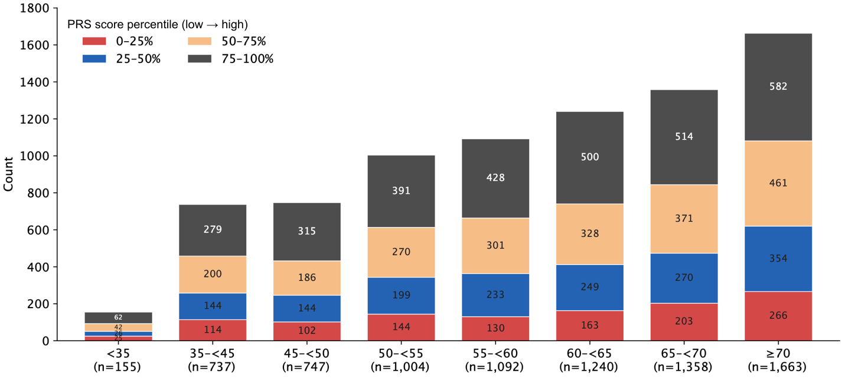
(b)
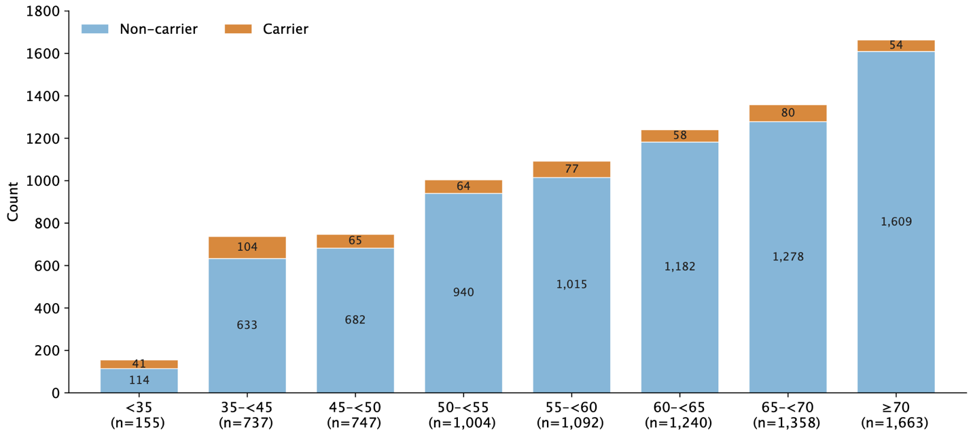

(c)
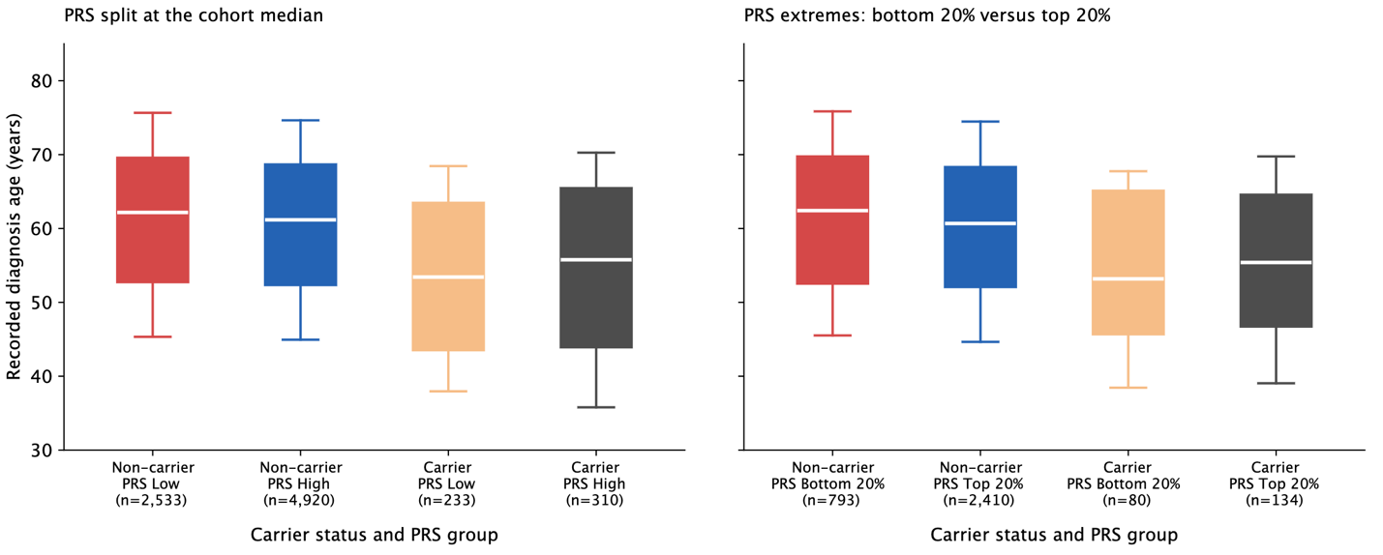
Figure 4. Recorded age at diagnosis by PRS and rare-variant carrier status among cases (n=7,996). (a) Counts of cases in each diagnosis-age band by PRS quartile; quartile cut points were defined in the full case-control cohort. (b) Counts of carriers and non-carriers in the same age bands. (c) Box plots of recorded age at diagnosis by carrier status and PRS group: the left panel splits PRS at the full-cohort median, and the right panel compares the bottom and top 20% of the full-cohort PRS distribution.
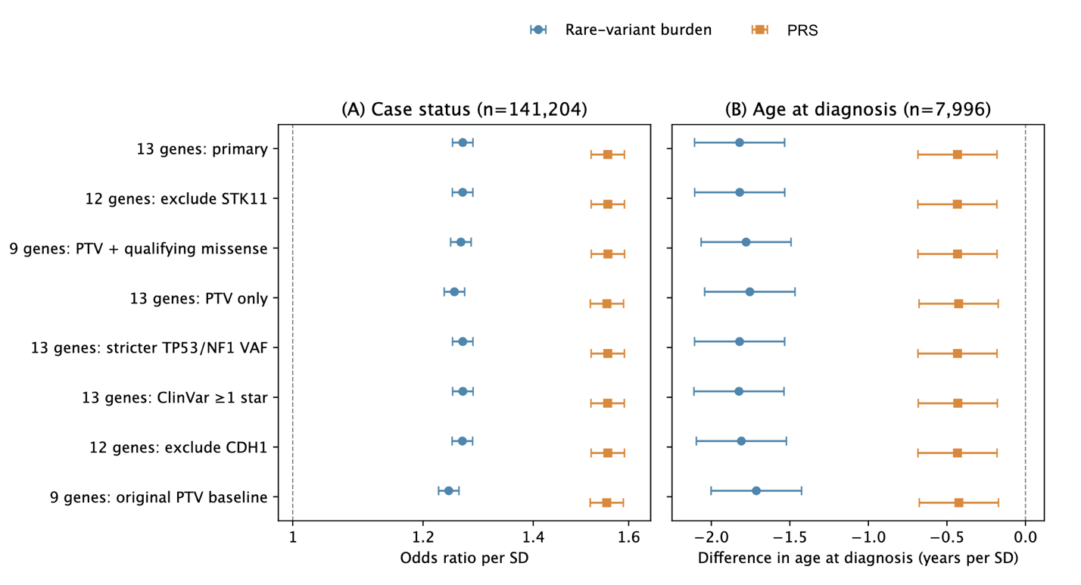
Figure 5. Case-status and diagnosis-age associations across rare-variant definitions. (a) Case-status odds ratios per standard deviation from the joint logistic model, including PRS, Burden_{rare}, their interaction, age at last EHR observation, PC1–10, sequencing center and sequencer model (n=141,204). (b) Difference in recorded age at diagnosis per standard deviation among cases from an OLS model including PRS, Burden_{rare} and PC1–10, sequencing center and sequencer model, without interaction (n=7,996). Points show Burden_{rare} in blue circles and PRS in orange squares; horizontal lines show 95% confidence intervals based on HC1 robust standard errors.
(a)
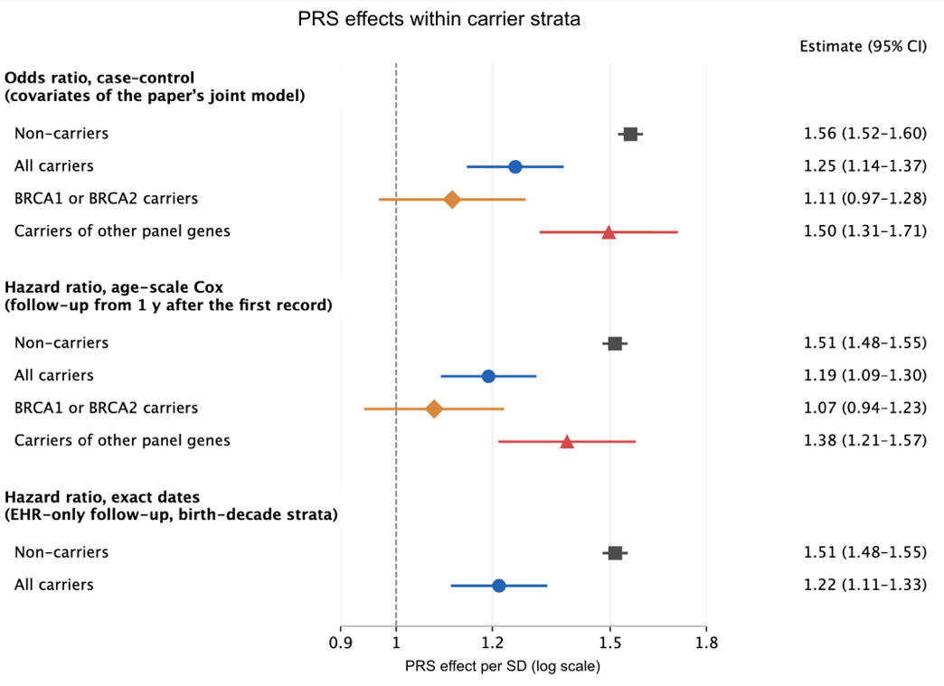
(b)
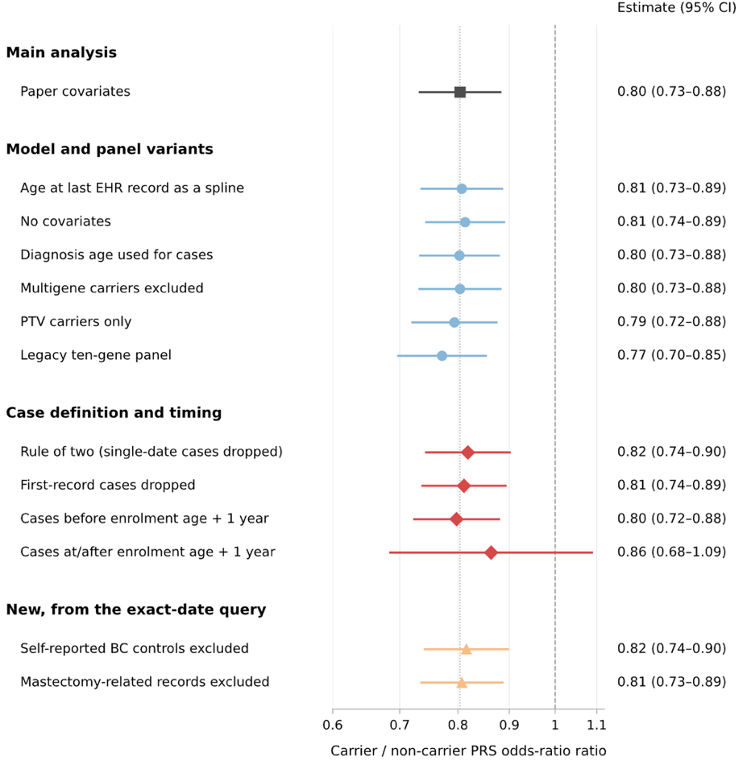
Figure 6. PRS associations with breast cancer risk by carrier status. (a) Odds ratios (ORs) per standard deviation of PRS from logistic models of breast cancer case status fitted separately in noncarriers and carriers, with estimates for BRCA1/BRCA2 and other panel-gene carriers. Age-scale Cox hazard ratios (HRs) are shown below the logistic estimates; an exact-date EHR follow-up sensitivity analysis appears at the bottom. (b) Ratios of the logistic PRS OR in carriers to that in noncarriers across the model, gene-panel and case-definition specifications shown. Points and horizontal lines indicate estimates and 95% confidence intervals; the vertical line in (b) marks a ratio of 1.

(a)
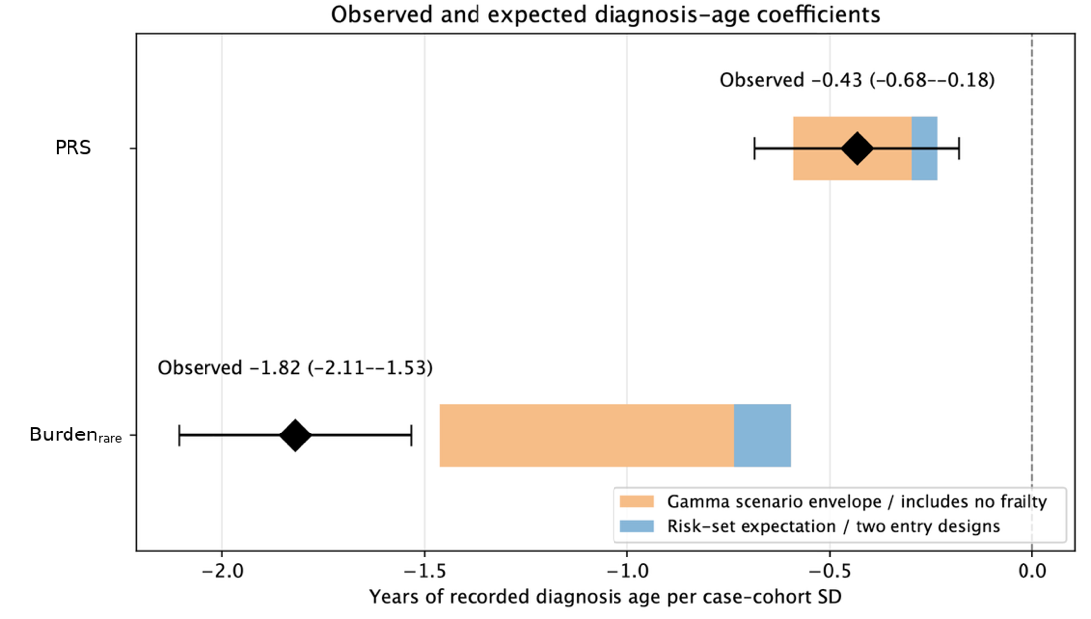
(b)
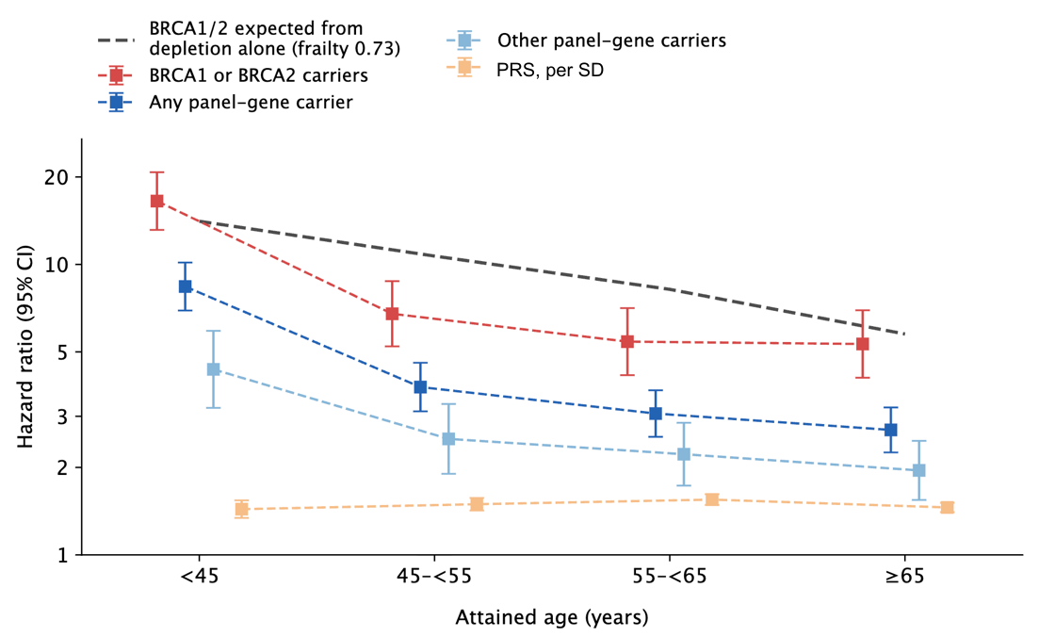
Figure 7. Diagnosis-age coefficients, age-specific hazard ratios, and frailty. (a) Diamonds show observed case-only diagnosis-age coefficients (Table 3). Blue bands show values expected from age-scale Cox risk sets under age-constant relative effects; orange bands span gamma-frailty simulations, including no frailty. (b) Points and 95% CIs show age-scale Cox HRs by attained age for PRS and carrier groups. The grey dashed line shows the BRCA1/BRCA2 decline predicted from high-risk-carrier depletion by the gamma-frailty model (variance 0.73).

